**Image processing HW1 Name:武敬祥 ID:b06611032**

**GUI**

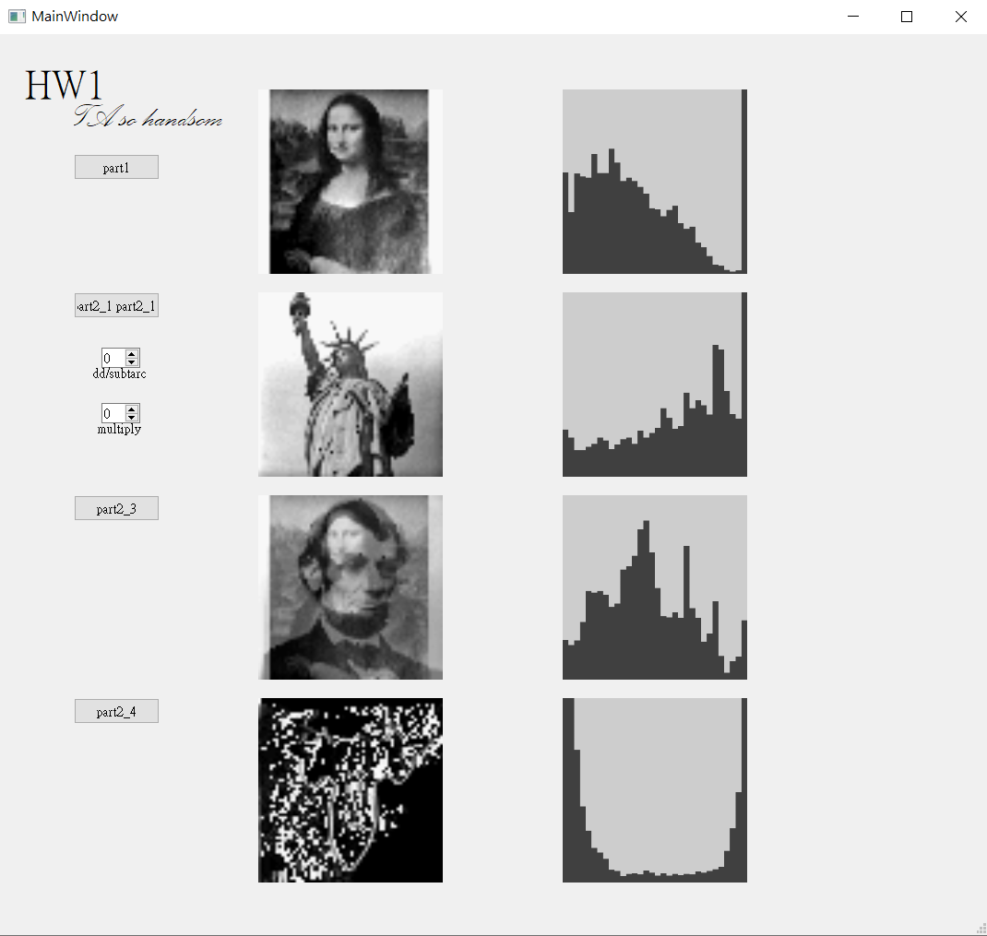

**Press button labeled to choose the .64 file**

**Part 1: Histogram of an Image**

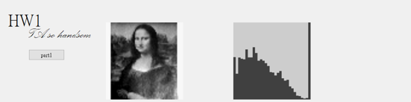

Using c++ package <fstream> to load the .64 file and encode 0~9 , A~Z into 0~31 in order to plot the histogram. Multiplying every pixels by 8 and using cv::resize, cv::point, cv::line to plot the image on the ui.

**Part 2: Arithmetic Operations of an Image Array.**

1. **Add or subtract a constant value to each pixel in the image.**

**n=0**

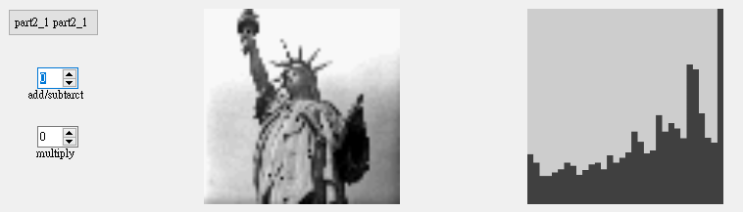

**n=10**

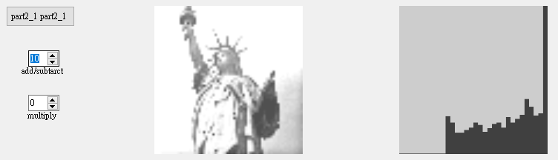

**n=20**

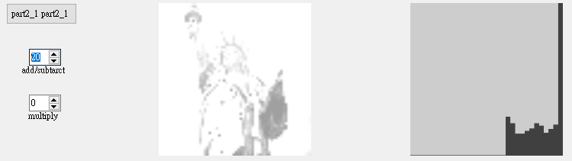

We can decide how much we want to add to every pixel by QSpinBox.

The above is a demonstration of Liberty to add every pixel by n=0, 10, 20, separately. The image is getting brighter when n is larger, and the value in the histogram will also fall into 31 gradually. On the other hand, if we subtract a constant number, the image will get darker.

1. **Multiply a constant to each pixel in the image.**

**n=0**

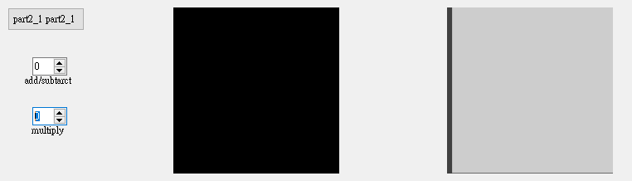

**n=1**

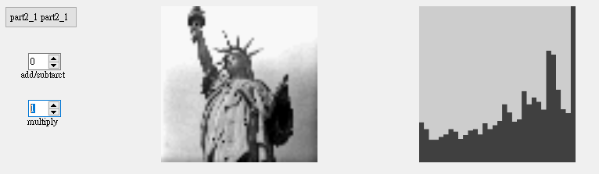

**n=5**

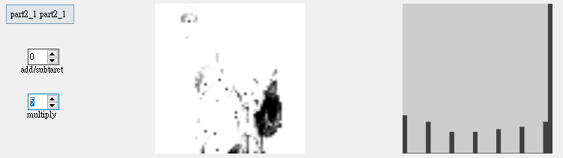

We can get a similar result like add a constant number to every pixel when we multiply a constant number to every pixels. the above is a demonstration of Liberty to add every pixel by n=0, 1, 5, separately. Notice that when the pixel value is 0. No matter how much we multiply the number to it, it will be 0 forever.

1. **Create a new image which is the average image of two input images.**

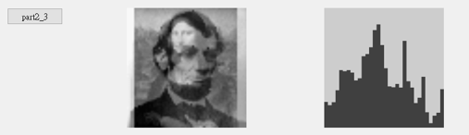

This two picture is a little transparent because their pixel values reduce by half.

1. **Create a new image *g*(*x*,*y*) in which the value of each pixel is determined by calculating the pixel values of the input image *f*(*x*,*y*) using the following equation:**

***g*(*x*,*y*) = *f*(*x*,*y*) - *f*(*x-*1,*y*)**

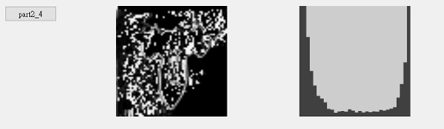

We can detect edges of an object by calculating its gradient.

And this manipulation can be regarded as a subtraction of adjacent pixels. As a result, we can detect the 1D edges in this demonstration.